Participation in the 9th Assembly of Petrology and Geochemistry. Senkút, September 6-8, 2018
This conference was organized by:
Márta Berkesi, Dóra Cseresznyés, Tamás Spránitz, Orsolya Gelencsér and Csaba Szabó
All members of the Hungarian Geological Society and specially from Lithosphere Fluid Research Lab, that I am also a member.
The conference took part on Senkút, on 6 and 7 of September, scientific talks where performed in geology, geochemistry, environmental geochemistry, urbano-geochemistry, volcanology, etc.
I have participated on the 6th of September in the second session at 13:15 with the topic “Theoretical and empirical models for estimation of soil gas radon concentration and permeability in the framework of geogenic radon risk assessment on a granitic area, Hungary”
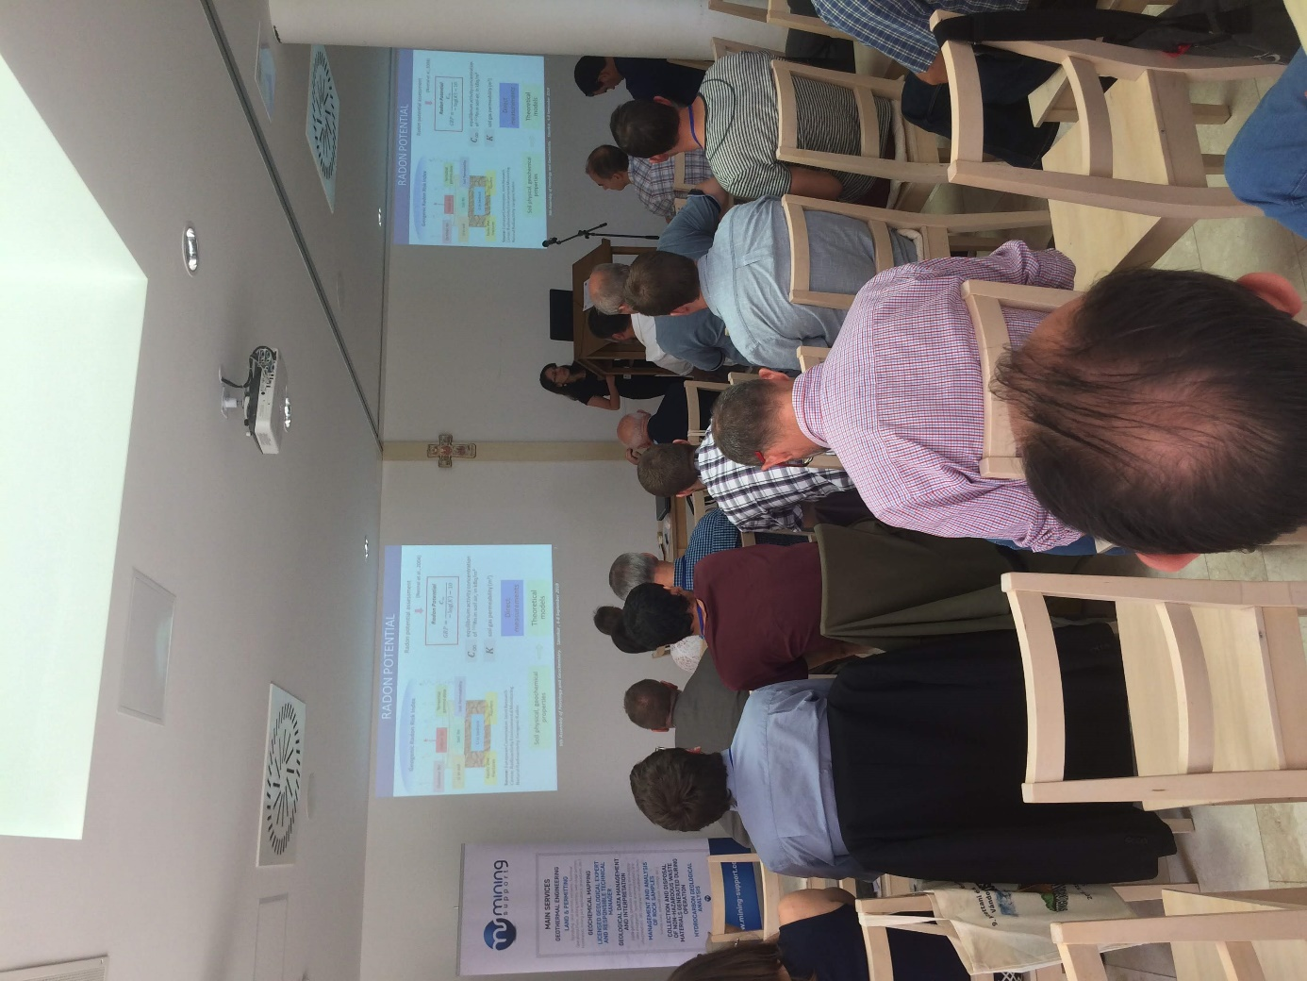
The last day, 8th of September, a field trip where organized from 9:00 to 18:00 in Sátorosi, Bárna, Salgótarjan and Szilvás-kő tanösvény
